

Bryan Long, Kara Osterman, Kia Sutton, Nick Wolcott

04/01/2024

**TABLE OF CONTENTS**

Section 1. Project Description

Executive Summary with Narrative and Conclusions 3

Company Background & Current Environment 4

Problem Analysis (BPA, BPI, BPR) 5

Proposed System Objectives and Constraints 6

Expected Benefits 7

Context Diagram 8

Section 2. Analysis

Executive Summary with Narrative and Conclusions 9

Use Case Diagram 10

Supplement Specifications (Non-Functional) 11

Section 3. Design

Executive Summary with Narrative and Conclusions 12

Complete Data Flow Diagram Package 13

Hardware and Software Specification 14

Navigation Diagram 15

Entity Relationship Diagrams 16

Program Plan showing logic and I/Os (IPO Chart with each program listed) 17

Section 4. Implementation

Executive Summary with Narrative and Conclusions…………………………………………………….18

Training Manual………………………………………………………………………………………..…19-25

Technical Manual………………………………………………………………………………………..25-35

Testing Plan ……………………………………………………………………………………………....36-37

Section 5. Post-Implementation

Executive Summary with Narrative and Conclusions…………………………………………………….38

Transition Plan

Migration Plan (Business, Technical, People Readiness) 39

Project Assessment

Lessons Learned during the project (by group) 40

Explanation of Challenges, Problems, and Discoveries 41

Appendix

All Burndown Charts, All Backlogs, All Meeting Logs 42-49

Any other supporting documentation

**SECTION 1: PROJECT DESCRIPTION**

**Executive Summary Section 1**

Section one will cover the company background and their current environment, the problem analysis, the proposed system objectives and constraints, the expected benefits of the new system, and a context diagram.

In the company background and current environment portion, we will be discussing the owner, Tony Brown, and their business, Tailored and Buffed Nail Co. Tony is a full-time bartender and a part-time nail technician. Due to a sharp decline in bookings, Tony is focusing more on bartending as they work to build their clientele back up. Due to time constraints, Tony is looking for ways to automate and improve current business processes. Our proposal is an online booking site that will allow clients to schedule, modify, and cancel appointments at their convenience. Tony will be able to update the site per their availability. Our team will be working throughout the semester to create and implement the system. With this system, we anticipate Tony will be able to improve customer service, increase efficiency, and grow their clientele while working their full-time job.

**Company Background and Current Environment**

Tony Brown is the sole owner and nail technician of Tailored and Buffed Nail Co. The business was started in 2018 with the mission of providing quality nail service for all at a reasonable price. Their services include sculpted sets, gel manicures, and acrylics with nail tips in various lengths and styles. The company relocated from Charlotte, NC to Atlanta, GA in 2022. The relocation and pandemic led to a sharp decline in bookings and lost clientele. Tony’s business is considered specialty due to the extensive training they have undergone, and premier services offered such as sculpted sets and Russian Almond shaping. Most of the clientele [75%], past and present, is comprised of repeat customers. Before the decline, Tony’s bookings allowed them to work at the business full-time. The business grew organically via word of mouth and social media posts by the business and its clients of their nails.

Currently, many of the business processes are manual and time consuming. Current and prospective clients often reach out via social media sites [primarily Instagram] or contact them via cell which is both their personal and business line. Appointments are typically made via text exchanges leading to their cell being inundated with messages from clients. This problem interrupts their personal and professional life and is the primary issue we are aiming to resolve with our system. Once appointments are scheduled, reminders and confirmations are sent out manually. Once the client has arrived, Tony accesses their nails looking for damage and existing nail sets. Clients are required to remove other technicians' work prior to their appointment. Additional fees are incurred if this rule is not adhered to. It also results in appointments either being canceled or a delay on later appointments. Services and prices are confirmed at the beginning of the appointment, but clients are allowed to add on/alter select services. Once service has been completed, customers pay via cash, Cash App, Zelle, or card.

**Problem Analysis**

Tailored & Buffed Nail Company Business Process Automation

Business Process Automation (BPA) is the process of using technology to replace manual information management processes. This can happen when a client is working towards saving costs and time to their processes. The end goal is to achieve a business process that is modernized to current business practices while being efficient and detailed.

In the case of Tailored & Buffed Nail Company, their current process for taking nail reservations requires complete manual effort. The current process is mostly “unofficial”, meaning it happens without accountability or reliability as it revolves around informal communication between individuals. As part of our automation process, we have decided to develop a web-based booking engine for Tailored & Buffed Nail Company. This new system would allow customers to book appointments online and receive confirmation and reminder emails. Manicurists in the system would then receive notification of new appointments and the ability to modify move or cancel said appointments.

**Proposed System Objectives and Constraints**

The system that we have chosen to propose is a newly designed website with an appointment booking system. The client will have access to book appointments at a specific time slot (required), select the type of service requested (required), and add any comments of nail inspiration to better help the staff of Tailored and Buffed Nail Co. prepare prior to the appointment (optional). Information will be updated to the salon database to clearly lay out appointments and information regarding appointment confirmation and reminders will be sent out to the client automatically. Management will be able to modify bookings.

The two constraints for us moving forward will be attempting to complete this system in the shortest time possible. Because this new website will lock in new, current, and past clients, the stress of completing this in a short span while ensuring it is functional for people of all ages to use is going to be weighing on us as a team. The second constraint we have found is getting over the learning curve of working on our most advanced web-based design system. Adding in everything from the entire booking system to making sure confirmations and reminders are sent out will be a challenge.

**Expected Benefits**

*Increased Efficiency and Revenue*  
The creation of this website will not only increase the efficiency of the business as a whole but will also increase functionality for Tony on a day-to-day basis. Having the ability to let the client create the first part of the nail service experience lets Tony focus on other functions of the business such as cleaning and inventory. As of right now with Tony trying to work clientele back up, appointments are only coming in around 10 times per week. With the implementation of the booking system, we expect Tony’s appointment volume to increase anywhere up to 4-6 bookings per day. This addition of appointments will be able to give Tony a revenue boost from an average of $900 per week to $1,800-$2,700 per week.

*Client Booking Experience*

Clients will have a much better booking experience, not having to wonder how long the manual response time will take to set up an appointment. The average time it will take to complete a booking via the new website is about 5-7 minutes, saving customers about 1-2 hours of lag time waiting on a response for a booking time from Tony.

**Context Diagram**

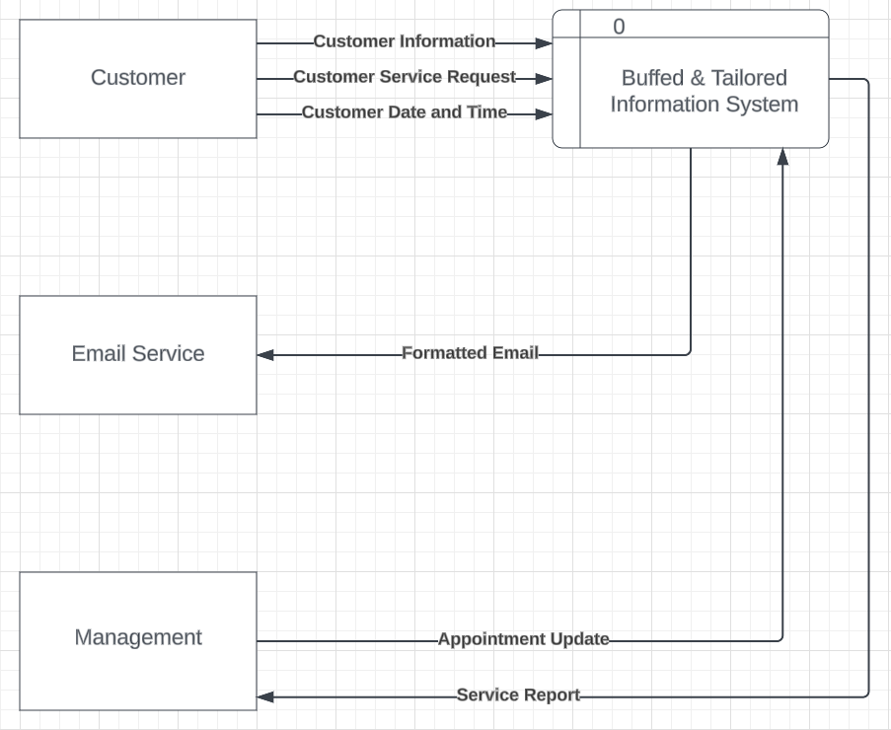

**SECTION 2: ANALYSIS**

**Executive Summary Section 2**

Section two contains the non-functional supplemental specifications and use case diagram which shows the main users of our IS. The first main user for our IS will be the customers who will schedule appointments and select the service that they would like to receive.

The second user is the management who will be able to view and interact with the IS. There are six main processes. First, customers will input their information. Next, they will select the service that they would like to have during their appointment. The database will store this information and the email system will respond with a confirmation to both the customer and to management. Once the information is stored in the database, management can generate service reports and edit service requests.

**Use Case Diagram**

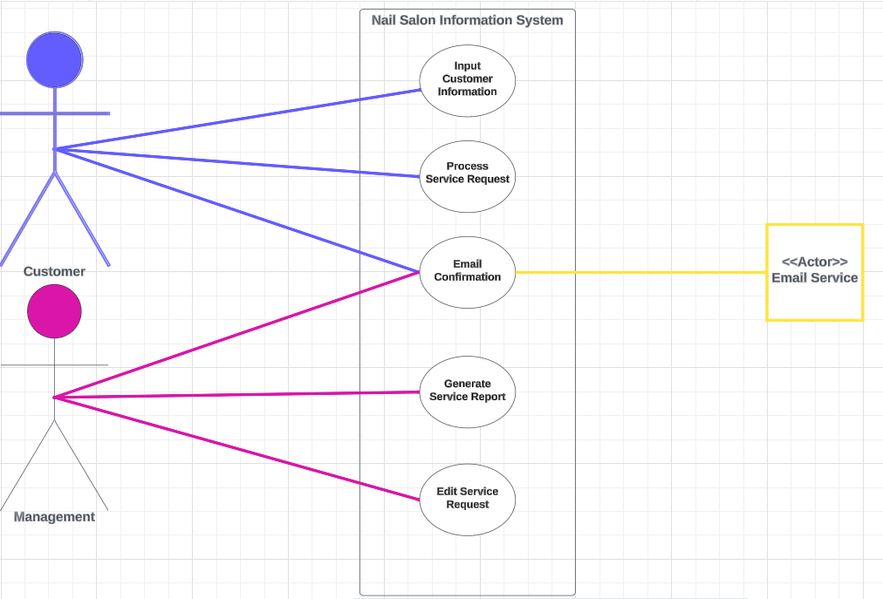

**Supplement Specifications (Non-Functional Requirements)**

**Operational:**

* Works on common modern web-browsers (Chromium, Firefox, Safari)
* The website is viewable on computer (desktop/laptop) and mobile (tablet/phone)
* The website is easy to modify and update themes/plugins
* The website has logical flow for end-users

**Performance:**

* Any interactions between the user and the system should not exceed 2 seconds.
* Users should be able to access the system 24 hours per day and 365 days per year.
* The system should update the database within 5 minutes of a change being made.
* Confirmation emails should be sent within 5 minutes of the client submitting the service request.

**Security:**

* Client data is not to be shared with outside parties.
* Access to modify or cancel bookings will only be granted to the owner.
* No credit card information is required to book which could pose a higher security risk

**Political:**

* Clients’ personal information is protected in compliance with the U.S. Data Protection Act
* The system will adhere to information protection rights

**Cultural:**

* System will use English as its language
* The system will not store unnecessary information

**SECTION 3: DESIGN**

**Executive Summary Section 3**

This section includes the complete data flow diagram package, hardware and software specifications, navigation diagram, the entity relationship diagram, the program plan/IPO chart, and the standard naming conventions.

The complete data flow diagram package illustrates how data flows through a system and the data about its entities and processes. The hardware and software specifications will describe what operating system, special software, hardware, and network data is available in our project. The navigation diagram will show how users will navigate through the website. The entity relationship diagram illustrates how the entities within our system relate to each other. The program plan will show the input, processing, and output for five programs. Lastly, the standard naming convention is character sequences to be used for identifiers that denote fields and variables in the system.

**Complete Data Flow Diagram Package**

**Level 0**

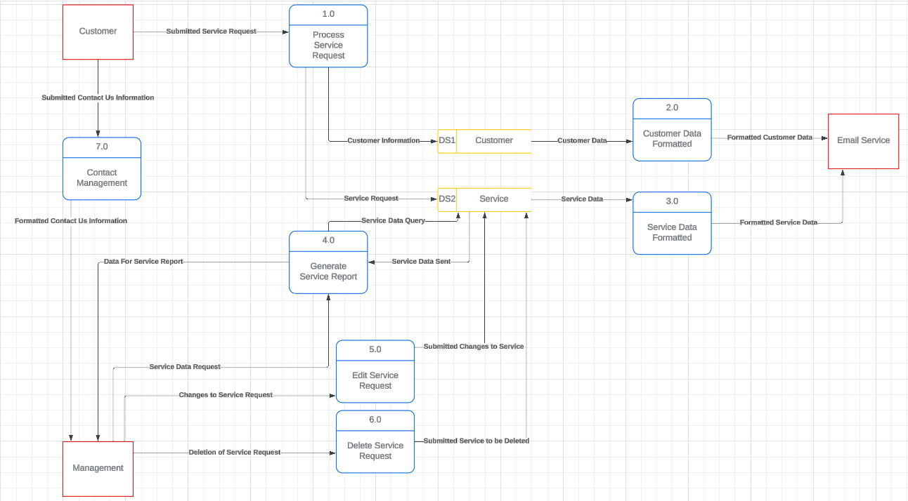

**Level 1**

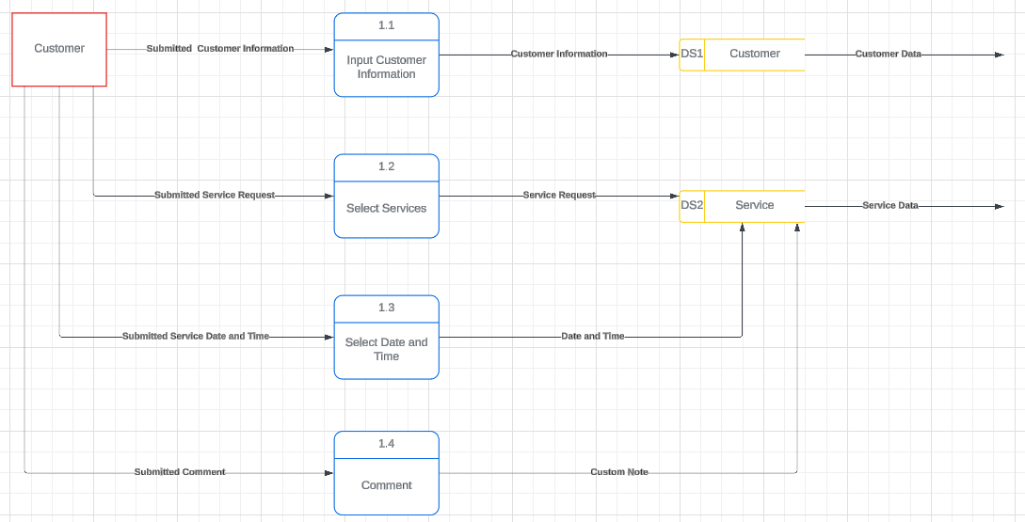

**Hardware and Software Specifications**

|  |  |  |  |
| --- | --- | --- | --- |
|  | Standard Client | Standard Web Server | Standard Database |
| Operating System | Windows or Mac or Linux | Linux or Windows Server | Linux or Windows Server |
| Special Software | Modern Web Browser (Chromium, Firefox, Safari) | Nginx or Apache Cpanel or  Hestia | MariaDB/MySQL |
| Hardware | Desktop or Laptop Computer Smartphone | VPS or hosted webserver with 4 cores, 8 GB RAM and 100GB Storage | VPS or hosted webserver with 4 cores, 8 GB RAM and 100GB Storage |
| Network | Wired or Wireless, ideally 10mbps+ | Gigabit or better wired connection | Gigabit or better wired connection |

**Navigation Diagram**

**Entity Relationship Diagrams**

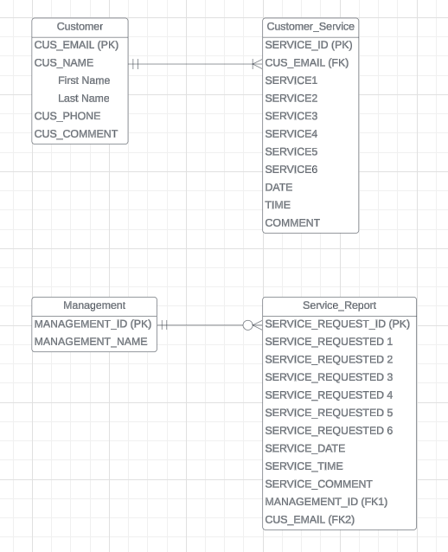

**Program Plan – IPO Chart**

|  |  |  |  |
| --- | --- | --- | --- |
| Program | Input | Processing | Output |
| Admin Login | * Admin username * Admin Password | * System verifies credentials   + IF: data matches     - THEN: grant access   + ELSE: access denied and display ‘Error: username/password entered is incorrect. Please try again or reset password’ | * Admin logged in |
| Reset Password Request | * Admin email address | * IF: email address in the database   + THEN: password reset link is sent * ELSE: display ‘Error: There is no account with that email address’ | * Password reset link sent to admin |
| Reset Password | * Admin clicks password reset link sent via email * Admin username | * IF: password matches criteria   + THEN: password is saved in database * ELSE: display ‘Error: password entered does not meet password requirements’ | * Reset Password |
| Book Appointment | * First name * Last name * Email address * Phone number * Selected services * Appointment date and time * Comment or Message | * Customer’s contact information is stored in database * Selected services are stored in database * IF: desired date is selected   + THEN: system will show available appointment times * ELSE: user will be prompted to select a date | * Appointment Booked * Confirmation message will display * Appointment information is sent to admin and customer |
| Contact Us Form | * Name * Email * Comment or Message | * System sends name, email, and content of message to admin | * Message sent to admin |

**SECTION 4: TRAINING & TECHNICALITIES**

**Executive Summary Section 4**

This section includes the training manual and technical manual. The training manual consists of step-by-step navigation of features of the website and our provided system. The technical manual consists of navigation of some possible changes that the client might want to make due to updates or issues with the system. This section also includes a test plan. The test plan goes over the primary form on the website, the appointment booking form. In this test proper functionality is validated to ensure consistent appointment bookings as well as email coomuncation.

**TRAINING MANUAL**

**Accessing Booking Information – MANAGEMENT ONLY**

1. Go to [https://dev.wolcotts.xyz](https://dev.wolcotts.xyz/)

2. To navigate to our login page, which allows management-only access for updating/editing appointments and generating appointment reports via WPForms, **click the “MENU” button** in the top right-hand corner. A list with options to click will appear on the left-hand side of the page as shown in the following image.

3. When the MENU list appears, **click “Login”.**

4. On the “Login” page, there will be two text boxes where you will input the username, as well as the password.

Enter the Username:

Enter the Password:

The two boxes will REQUIRE the accurate pre-set login credentials as noted by the red asterisks. If you would like your browser to remember the login (recommended for quick access) check the “Remember me” box and finally **click “SUBMIT”.**

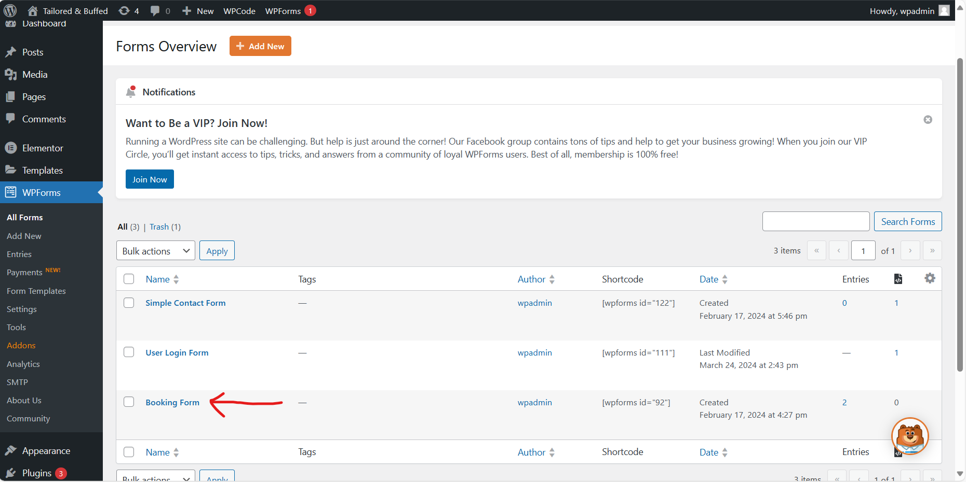5. After entering the correct login credentials, WPForms will appear and launch its “Forms Overview”. To edit a customer entry, scroll down if needed and **click the “Booking Form” link** as noted by the red arrow to open up customer booking information.

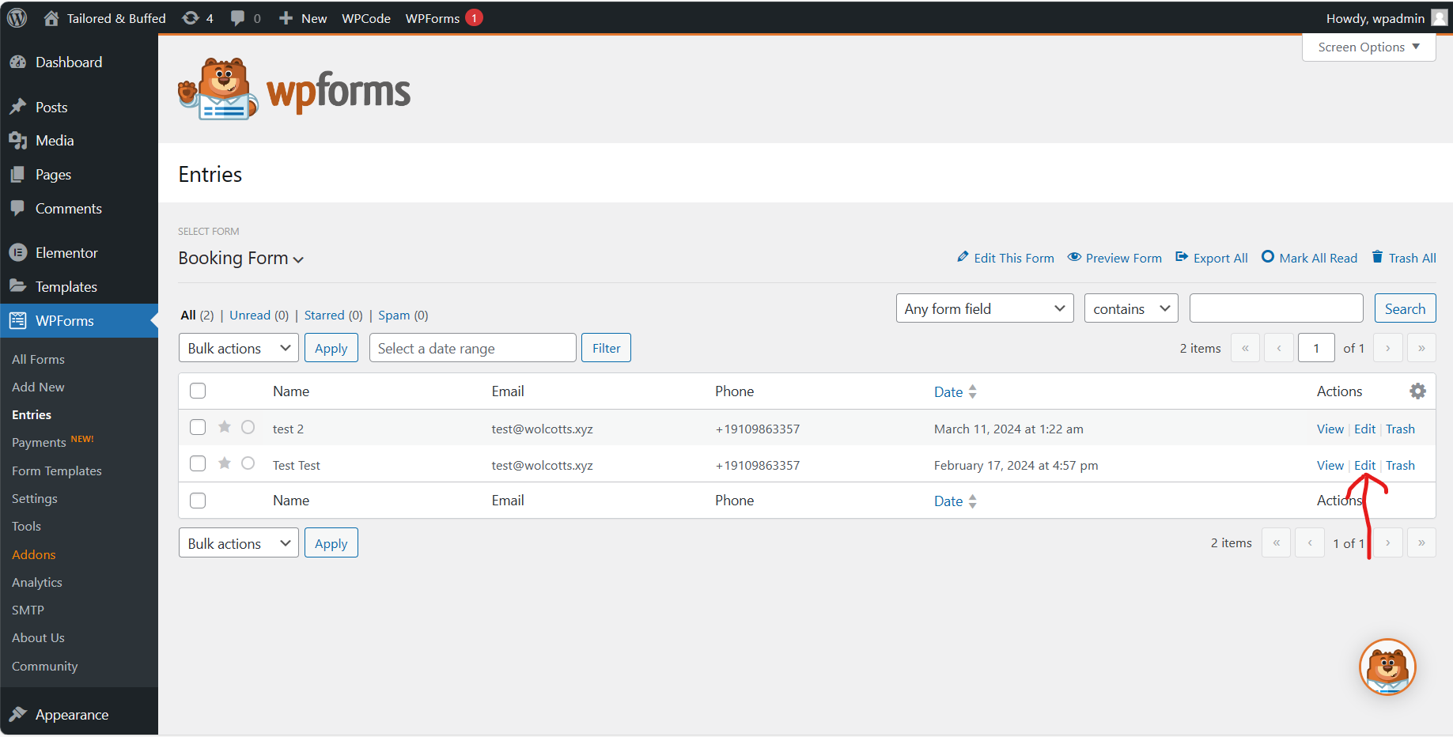6. Under the Booking Form, you will find a list of all bookings submitted by customers. The table will show all information including the name, email address, phone, date, and actions for the booking. We want to edit the entry so we will navigate to the actions column. This column has three options, view, edit, and trash. **Click “Edit”.**

7. The “Edit Entry” page will open which contains all information about the booking. Management will select each field that needs to be changed and make the change requested by the customer. For example, if the customer has requested to change the date and time of their booking. Management will navigate to the date field and enter the new date in XX/XX/XXXX format. Afterwards, they will change the time in the time field that follows. Once the changes have been made, management will **click the “Update” button** which will save the changes in the database.

**Generate a Report**

8. While under WPForms > Booking Form > Entries, click in the date range box and select a date range for which you would like to see reports for. **Click ‘filter’** to view booked appointments within the selected time frame. The below pictures shows all bookings [without a filter being applied].

Below is a report with a date range of 03/01/2024 – 03/30/2024 applied.

**Disclaimer:** Document is subject to changes pending web host.

**Creating a Console Connection Key**

1. Go to <https://www.oracle.com/cloud/>
2. Click “Sign in to Oracle Cloud”

1. Enter cloud account name (nickwolcott)

1. Sign in with credentials and perform MFA

1. Open the Hamburger Menu in the top left corner (3 horizontal lines) then go to Compute then Instances.

1. Select the instance running the webserver

1. In the Left “Resources” menu, select “Console Connection” then “Create Local Connection”

1. Save the private key and Public Key.

**Setting Up and Using PuTTY to Connect to Server**

1. Go to <https://www.putty.org/> and click “Download “PuTTY”

1. Select the hyperlinked .msi file for 64-bit x86.

1. Run the installer with defaults.
2. Open PuTTY
3. Enter in the username and host IP address as [*username*@*xxx.yyy.zzz.aaa*](mailto:username@xxx.yyy.zzz.aaa) ([ubuntu@130.61.41.182](mailto:ubuntu@130.61.41.182))

1. In the left menu, go to Connection, SSH, Auth, Credentials

1. Under “Private Key File for Authentication” browse for the recently downloaded private key

1. Return to Session, name the session and press “save”

1. Open the session

1. Check for updates by running:

Sudo apt update

Sudo apt upgrade

Enter “Y” when asked to continue

**Accessing the Web Control Panel**

1. Go to <https://cp.wolcotts.xyz:8083/>
2. Log in

**Test Plan Page 1 of 2**

**Program ID:_____________ Version Number 1**

**Tester: Nick Wolcott Date Designed: 02/15/2024 Date Conducted: 04/28/2024**

**Results: Passed Open items: N/A**

**Test ID: 01 Requirement addressed: The form submits an email to the Manager after completion**

**Objective:**

**To ensure all fields behave appropriately within their constraints and that a confirmation email is sent out after the form is completed.**

**Test cases**

**Interface ID Data Field Value Entered**

1. BookFrm1 All fields are completed ­­______ Pass

2. BookFrm1 Some fields aren’t completed Fail

3. BookFrm1 Email reminder is received by Customer Pass

4. SgrdIntf1 Email is received by Manager Pass

5. SgrdIntf1 User selects same day appt Fail

6. BookFrm1 User selects appt outside of 2 weeks Fail

**Script**

In this test the form was tested to ensure that all required fields are filled out as well as automated emails are being sent. Pass means the task behaved as expected and the user actions went through. Fail means the task failed as expected and did not allow the form to be submitted.

**Expected Results/Notes**

If all required fields are not filled out, the form should alert the user and not allow submission. If all the fields are filled out, the form should be submitted, and the Manager is notified.

**Actual Results/Notes**

The form behaved as expected. If not all the fields were filled out, the user was alerted and not allowed to submit the form. When all the fields were filled out, the form could be submitted. Once a form was submitted the Manager received a notification email and the client received a reminder email the night before their appointment.

**SECTION 5**

**Executive Summary Section 5**

This section includes the migration plan which includes people, business, and technical readiness details. Section five also includes challenges, problems, and discoveries generated during post-implementation. Lastly, this section includes lessons learned by the group during the project.

**Migration Plan**

**Business Readiness:** We will be utilizing a direct conversion strategy to immediately replace the old system that we are automating. The website that we have created has been designed to automate several key business processes that were being performed manually. The direct conversion strategy will likely take a short time to adjust to, however we have purposefully created a system that should be intuitive for end users. Management will require some training on updating and deleting bookings, but our training and technical documentation includes a step-by-step guide for these processes that will be easy to follow and will allow any potential new employees to learn from as well. The contingency plan in the event of a system issue is for the business to return to the old system until the issue can be resolved.

**Technical Readiness:** The client should understand the software and technical components necessary for their website. They will need a proper internet/browser to access WordPress. Additionally, the client will need to be able to successfully navigate the WordPress site. Lastly, the client will need to employ a host for their website [or become familiar with the Hestia control panel for DB and webserver visibility]. Training will cover the hardware, software, and technical acumen necessary for their website. Our full report includes a technical manual if further assistance is required.

**People Readiness:** The two factors of “people readiness” comes from our client and the users of the system, the customers. As of right now, our plan for making sure that both groups are ready for the implementation of the new system is going to be determined by our client having proper training of the works of the system and that the system is easy enough to be navigated easily by the users. The client will most likely start to share the new system by word of mouth, and then put the website on various social medias, to reach the largest audience and gain the most business possible.

**Lessons Learned by the Group**

*Know your target audience*

Whether you are creating documentation or designing your system, it is imperative that you know who your target audience is and that you design every part with them in mind. As people with technical skills and knowledge, it would be easy to design a system that does not work for non-technical people. For instance, trying to get someone with no knowledge about how a database works to query the database using SQL would not work. We need to understand our clients and the users well enough to know what their limitations are and then design our information system accordingly.

*Just because it is a plugin doesn’t mean it all works together (Nick)*

WordPress is awesome for building a feature-risk website quickly. It is full of themes and plugins for almost anything you want to do. However, this can easily lead you astray. Just because it’s available doesn’t mean that it is going to work with everything else. Plugins are often made in a vacuum - unless they’re made by the same author(s). Because of this, it is impossible to guarantee that two plugins that may look awesome for your site will work. You may have to create workarounds yourself like I had to with the WPForms and the ability to send follow-up reminders. I had to build a python script to fetch appointment details from the WPForms database, format the data, then send it to an API for SendGrid to ensure the clients got their reminder emails the day before.

*Review and rehearse presentations to increase confidence in product*

Something that was learned early on in this project was to get as close to perfection as possible on presentation etiquette. We noticed that the sprints we did not put as much time into rehearsing our presentation, both our timing and flow were off and it reflected in our grade. Not only will stronger presentation skills help in school projects, having a stronger confidence in what you are presenting will take you farther in your professional life as well.

*Leave adequate time to schedule team meetings*

Another lesson we learned was the importance of leaving scheduling team meetings at least 4 to 5 days in advance.

**Challenges, Problems, and Discoveries**

**Challenges:** A challenge we uncovered was adequately preparing the people to utilize the system. Specifically, the main challenge faced was with getting the salon’s customers acclimated to the new booking system.

**Problems:** A problem we encountered was not being able to interact with the salon’s customers directly. This made building and beta testing the website difficult.

**Discoveries:** We discovered that working with the client throughout the semester allowed us to get timely feedback from an owner and nail tech perspective.

**Appendix**

**Burndown Charts**

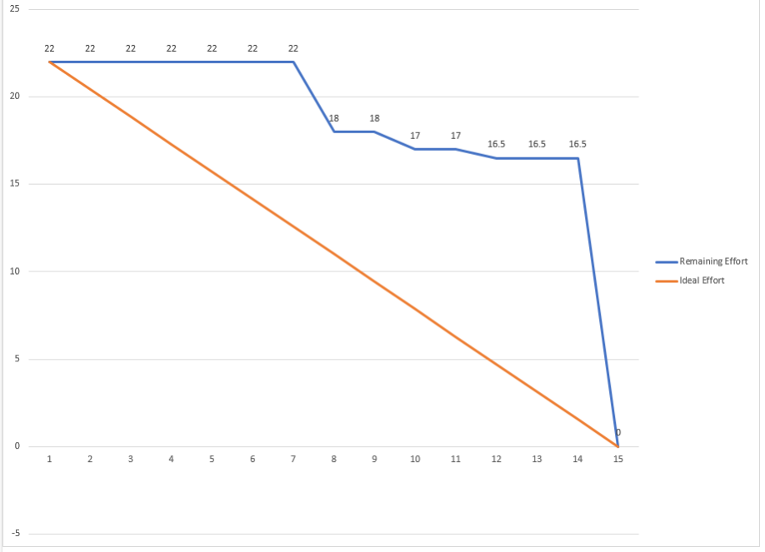

**Backlogs**

**Meeting Logs**

